Index Page Definitions

Background Color: #000;

Font-family: Helvetica, Sans-Serif;

BLOODLINES

The Art and Life of Vincent Castiglia

A JOHN BOROWSKI FILM

Font-color: #fff;

Page-wrap Properties:

* text-align: left;
* width: 1100px;
* margin: 0 auto;

Image Properties:

* display: block;
* margin-left: auto;
* margin-right: auto;

SYNOPSIS

TRAILER

* width: 50%;
* position: absolute;
* top: 25%;
* left: 25%;

Button Properties:

* background-color: rgb(26, 24, 24);
* height: 50px;
* width: 90px;
* color: #bb0404;
* border: #bb0404 2px solid;

f



* font-size: 16px;



Social Media Properties:

Will be custom social media icons with gradient background and appropriate logo for outlet.

Synopsis Page Definitions

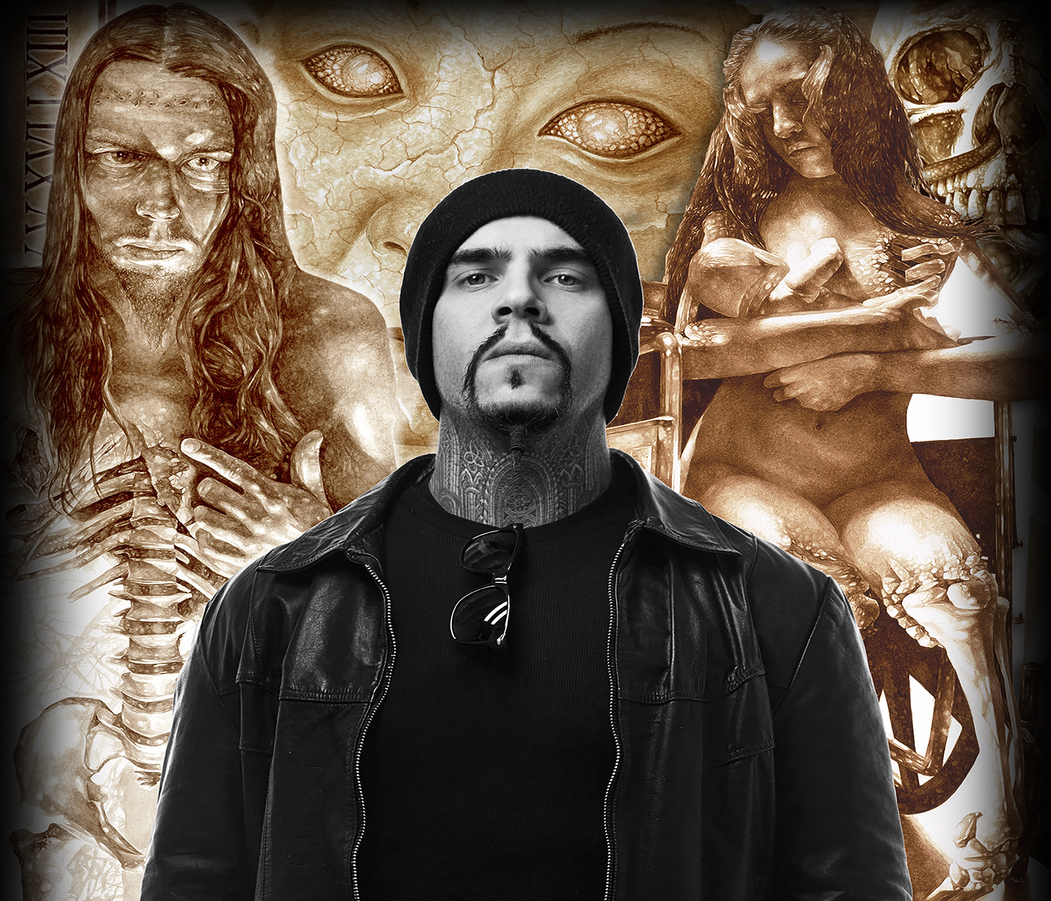

TRAILER SYNOPSIS DIRECTOR ABOUT PRESS CAST CONTACT FAQ



Navigation Bar Properties:

font: philosopher 14pt;

background color: #000;

position: fixed;

link color: #bb0404;

background image: cropped movie poster without credits

This page includes a vertical slide transition as the user scrolls down the next feature set will transition upward.



Page Transition Definitions



TRAILER SYNOPSIS DIRECTOR ABOUT PRESS CAST CONTACT FAQ

Background will be dark gray/ off black;

Background image: cropped movie poster;

Text color: white (#fff);

SYNOPSIS

Vincent Castiglia paints in human blood. The haunting, yet beautiful, images are of human bodies in various forms of decay. Award winning indie filmmaker John Borowski (H.H. Holmes: America’s First Serial Killer) has directed and produced the feature documentary film on the art and life of Vincent Castiglia.

The reasons why Castiglia began painting in blood are explored in this emotional rollercoaster ride portrayed on film. Borowski stated, “This is a deeply personal film for Vincent and I am honored to have worked closely with him on the film. I feel many people will see this film as inspirational, even though it is a dark ride through pain and suffering. Vincent’s life journey, much like his art, reflects both the dark and ultimately the light that shines through the darkness.”

Margaret Cho, who commissioned Vincent to paint her portrait in her blood, is interviewed in the film as well as celebrities Gregg Allman, Damien Echols, Kerry King and Gary Holt of the heavy metal band Slayer, record executive Michael Alago, and numerous others including filming in the Switzerland studio and museum of legendary artist H.R. Giger, who designed the iconic creature for the Alien movies.

CELEBRITIES INTERVIEWED

* Margaret Cho, Actor/Comedian
* Greg Allman, Musician, Allman Brothers Band
* Damien Echols, Ex-Death Row Inmate, West Memphis Three
* Kerry King and Gary Holt, Musicians, Slayer
* Randy Blythe, Musician, Lamb of God
* Tom Gabriel Fischer, Musician, Tryptikon
* Martin Eric Ain, Musician, Celtic Frost
* Michael Alago, Record Executive
* And more!

Each page of the epk should feature a different still from the movie, the transition will house the information related to the specific page.